FLYRANK ML INTERNSHIP CAPSTONE RESEARCH PAPER
Refresh Priority Scoring
Predicting Content Click Decline from Historical Search Console Signals to Build a Ranked Content Refresh Queue

Research Lane: Refresh / Content Opportunity Scoring
Author: Arslan Asim
Program: FlyRank ML Internship
Date: September 2026
Data: FlyRank ML Internship Warehouse (Hugging Face) public safe release

Title & Abstract
Title: Refresh Priority Scoring: Predicting Content Click Decline from Historical Search Console Signals
This paper asks a narrow, practical question: using only what a content team already has on hand at review time 30 days of prior search performance can a model tell them which pages are about to lose clicks, well enough to beat simply eyeballing the numbers? To answer it, roughly 651,000 historical 30 day observation/outcome window pairs were built from a 78.8 million row daily performance warehouse spanning 70 client accounts and 17 months, a decline was defined as a 40% or greater drop in clicks between consecutive windows, and four candidate models a rule style logistic regression baseline, an expanded logistic regression, a random forest, and a small neural network were trained on a strictly chronological train/test split so that no future information could leak into the features. The best performing model, a random forest using only four Search Console–derived signals (impressions, clicks, click through rate, and average position), reached a ROC AUC of 0.722 against a baseline of 0.702 and, at an operating threshold tuned for recall, correctly flagged 75% of genuinely declining content while keeping accuracy above 66% on 215,552 held out cases. The improvement over the baseline is real but modest, and adding engagement data from Google Analytics 4 did not help a finding treated here as informative rather than disappointing, since GA4 coverage was inconsistent across accounts and the extra features mostly added noise. The result is packaged not as a single accuracy number but as a ranked, reason coded action list a starting point for a content team's weekly triage queue rather than a verdict on any individual page.

Introduction & Problem Statement
A content team managing hundreds of thousands of published pages cannot manually re read every article to decide what needs attention. Some pages are quietly losing clicks; others are stable or growing; a large middle group is neither clearly failing nor clearly succeeding. Left unmanaged, this is exactly the kind of decision that consumes disproportionate editorial time on the loudest or most recently discussed pages rather than the ones that would benefit most from a review.
The decision this work supports is a scheduling decision, not a diagnostic one: given a large content inventory and limited hours, which items should a team look at first? A ranked list, even an imperfect one, changes how that hour is spent. The practical target is therefore not a perfect forecast of every page's future, but a prioritization signal that is measurably better than no model at all and honest about how much better.
Framed as a machine learning problem, this is supervised binary classification followed by ranking: given a content item's behaviour over a 30 day observation window, predict whether its clicks will fall by a meaningful amount over the following 30 days, then rank the flagged items using the model's confidence and a small set of interpretable reason codes so that a reviewer understands not just that a page was flagged, but roughly why.

Data

Release and Access
The analysis uses the FlyRank ML Internship warehouse hosted on Hugging Face (FlyRank/internship warehouse), accessed read only through DuckDB queries against the remote Parquet files rather than downloaded in full. This kept the working set to query results in the tens of thousands to low millions of rows at a time instead of materializing the full warehouse locally.

Tables Used
- dim_clients (104 rows) one row per client account, including each account's Search Console data start date, used to bound each account's valid history.
- dim_content (519,606 rows) one row per content item, including creation/update dates, optimization history, and publish/delete status.
- fact_content_daily_performance (78,835,655 rows) the core daily fact table: Search Console impressions, clicks, and average position, plus Google Analytics 4 pageviews, sessions, users, and engagement metrics, one row per content item per day.
- fact_content_query_90d (2,414,248 rows) a query level, 90 day rolling snapshot table. This table was inspected but excluded from feature engineering (see below).

Date Window and Coverage
The daily performance table covers report dates from 2025-01-27 through 2026-06-30 approximately 17 months across 427,292 distinct content items and 70 distinct client accounts. Coverage is uneven by design: each client's data begins on its own Search Console connection date rather than a single shared start date, so the number of usable observation days per content item varies widely (median 218 days, mean 184.5 days, range 3–520 days across the full history).
Three client accounts were excluded from all downstream analysis. Each had daily fact rows present but zero non null impression signal across their entire observed history an artifact of account level connection issues rather than genuine zero search visibility so including them would have silently mislabeled inactive accounts as declining content.
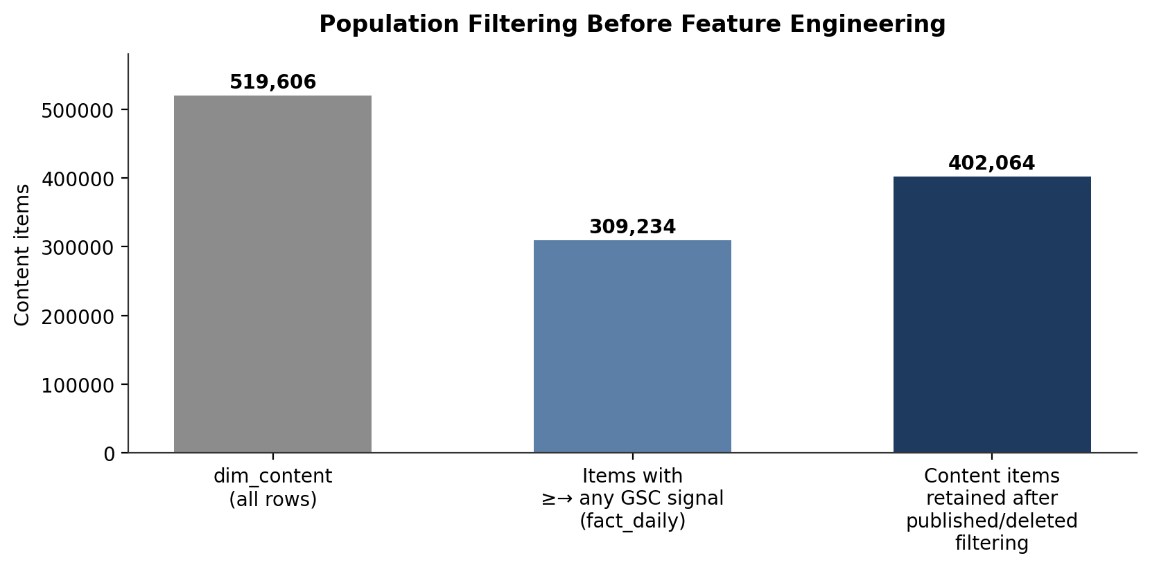
Figure 1. Content population after joining the content dimension to the daily performance fact table and applying publish/delete status. All three groups were retained for feature engineering; publish/delete status was used only as a post hoc filter on final recommendations, not as a training population cut (see Methodology).

Exclusions and Public Safety Notes
- No client names, domains, URLs, credentials, or raw exports appear anywhere in this paper or its supporting notebooks; all identifiers are the warehouse's pre anonymized content_hash_id / client_hash_id values.
- fact_content_query_90d was excluded from modeling. Its window bounds (2026 04 02 to 2026 06 30) are fixed and identical for every row it is a single global snapshot, not a per content, time varying table so it cannot support the sliding observation/outcome window design this project needs without introducing leakage. It remains useful only for one off, descriptive exploration outside the modeling pipeline.
- dim_content's optimization_eligible_date field was dropped: it is a deterministic function of last_optimized_date plus a fixed 45 day cooldown, confirmed across every non null row, and therefore carries no information beyond what last_optimized_date already provides.
- No claim in this paper attributes any observed change to a specific Google algorithm update or asserts a causal mechanism behind a ranking or traffic movement; all findings are described as observed, statistical associations within this dataset.

Methodology

Prediction Design
Every training example follows the same shape: a 30 day observation window supplies the predictors, and the following, non overlapping 30 day outcome window supplies the label. The prediction is made at the boundary between the two windows, using only information available up to that point no signal from the outcome window is permitted to influence a feature. This boundary is treated as a hard constraint throughout the pipeline rather than a guideline, and is checked directly (see Leakage Checks below).

Target Definition
Before fixing a threshold, the raw distribution of period over period change was examined at several minimum volume cutoffs, since very low traffic content produces extreme, meaningless percentage swings (a page going from 1 click to 0 clicks is a “100% decline” that says little). Restricting to items with at least 100 observation window impressions stabilized the distribution: median relative change moved from roughly –46% at a 10 impression floor to a more consistent –39% at a 100 impression floor, with diminishing change beyond that point.
Decline threshold | Eligible items | Declining items | Decline rate
≥ 20% drop | 111,247 | 71,592 | 64.4%
≥ 30% drop | 111,247 | 63,611 | 57.2%
≥ 40% drop | 111,247 | 54,479 | 49.0%
≥ 50% drop | 111,247 | 43,916 | 39.5%
Table 1. Candidate decline thresholds evaluated on a single exploratory snapshot window (items with ≥100 observation window impressions). A 40% threshold was selected because it isolates a substantively meaningful decline while keeping the resulting label close to balanced, which matters for a classifier trained on a limited feature set.
The final target definition: a content item is labeled declining (1) when its clicks in the 30 day outcome window are at least 40% lower than its clicks in the preceding 30 day observation window, restricted to items with at least 100 impressions during the observation window. Every candidate window was built as a non overlapping, per content 30 day pair across each item's full history, yielding 651,458 labeled window pairs with a near balanced class split of 50.7% declining to 49.3% not declining (an earlier, overlapping window construction produced a much larger but redundant 18.3 million row set at 22.3% positive; the non overlapping version was adopted as the modeling dataset because it removes the strong autocorrelation of near duplicate sliding windows.)

Leakage Checks
Two checks were run before training. First, every predictor is computed with a strict date filter against the observation window only, joined by content_hash_id and window bounds the outcome window is queried solely to compute the label and is never joined into the feature set. Second, the label logic itself was audited directly: of the 330,022 positive labels, zero violated the stated rule (i.e., zero had outcome clicks greater than 60% of observation clicks), confirming the SQL window logic matched the stated definition exactly.

Population Filtering
Publish and delete status (is_published / is_deleted) in dim_content were examined as a possible pre training filter but were not found to track meaningfully with the decline signal itself, and using them to exclude content before labeling would have removed items that still had valid, learnable performance history. They were instead reserved as a post hoc filter, applied only to the final ranked recommendation list, since a deleted item's current status reflects where it stands today rather than an event that happened within a given historical window.

Feature Sets
Three feature sets were compared, each built exclusively from observation window aggregates:
- Baseline (3 features): observation window impressions, clicks, and click through rate a deliberately minimal set meant to represent what a simple, rule of thumb heuristic would already have access to.
- Expanded (9 features): the baseline three plus average search position, and five Google Analytics 4 engagement signals pageviews, sessions, users, engaged sessions, and total engagement seconds.
- GSC only, final (4 features): impressions, clicks, click through rate, and average position the expanded set with GA4 removed, adopted as the final feature set once GA4 was shown not to help (see Results).
GA4 signals were missing for 414,423 of 651,458 window rows (63.6%) because Google Analytics is not connected for every client account, and were filled with 0 for those rows rather than dropped, so as not to shrink the training set.

Validation Design
The dataset was split chronologically rather than randomly, reflecting the real deployment scenario of training on historical behavior and predicting forward: the split point sits at the 80th percentile of observation window start dates. Training uses windows starting 2025 01 27 through 2026 02 21 (435,906 rows); testing uses windows starting 2026 03 23 through 2026 04 22 (215,552 rows). The roughly one month gap between the end of the training period and the start of the test period corresponds to the outcome window length itself, so no training example's outcome window can overlap a test example's observation window.

Models Compared
A logistic regression on the baseline feature set served as the primary comparison point throughout it is simple, fast, and interpretable, which is a fair proxy for “what a team could already infer by eyeballing impressions and clicks.” Against it, a logistic regression, a random forest (100 trees, max depth 12, minimum 20 samples per leaf), and a small multilayer perceptron (three hidden layers of 64/32/16 units with early stopping) were trained on the expanded 9 feature set. Once the expanded set was shown not to outperform the baseline meaningfully, a final random forest was trained on the GSC only 4 feature set to isolate whether the gain (if any) came from average position rather than from GA4.

Results

Model Comparison
All models were evaluated on the identical, untouched chronological test set. Table 2 and Figure 2 summarize the six evaluated configurations.
Model | Accuracy | Precision | Recall | F1 | ROC AUC | PR AUC
Baseline Logistic Regression (3 GSC feat.) | 0.639 | 0.648 | 0.736 | 0.689 | 0.702 | 0.736
Logistic Regression, expanded (9 feat., unscaled) | 0.606 | 0.656 | 0.580 | 0.616 | 0.661 | 0.700
Logistic Regression, expanded (9 feat., scaled) | 0.626 | 0.665 | 0.631 | 0.648 | 0.671 | 0.712
Random Forest (9 feat., GSC+GA4) | 0.665 | 0.719 | 0.630 | 0.671 | 0.716 | 0.758
Neural Network (9 feat., GSC+GA4) | 0.659 | 0.720 | 0.610 | 0.661 | 0.708 | 0.754
Random Forest, GSC only (4 feat.) final | 0.667 | 0.721 | 0.633 | 0.674 | 0.722 | 0.762
Table 2. All metrics computed on the held out chronological test set (n = 215,552) at the default 0.50 probability threshold, except where noted otherwise in the threshold tuning discussion below.
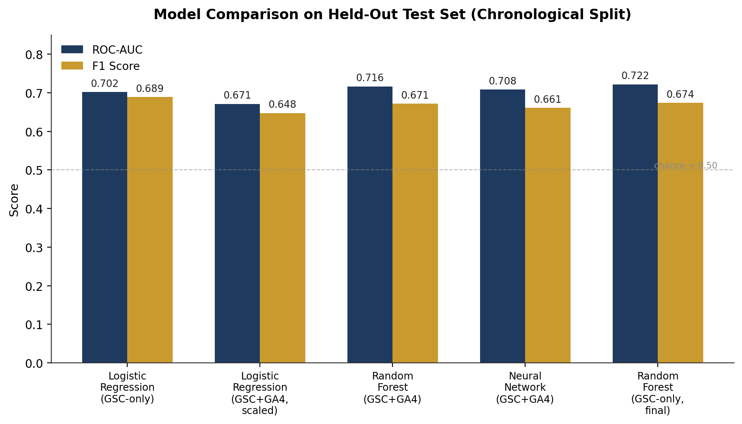
Figure 2. ROC AUC and F1 across all six evaluated configurations. The GSC only random forest edges out every other configuration, including the richer nine feature models.
Two results stand out. First, the improvement over the baseline is consistent but modest roughly 2 points of ROC AUC (0.702 → 0.722) which is the honest scale of what 30 days of Search Console history can tell you about the next 30 days. Second, and more instructive, adding Google Analytics 4 engagement data and a more expressive model did not help: the expanded logistic regression underperformed the three feature baseline outright, and even the expanded random forest and neural network only matched, rather than clearly beat, the simpler GSC only random forest. The most likely explanation, supported by the 63.6% missingness rate in GA4 fields, is that GA4 coverage gaps introduced more noise than signal; this reads as a genuine negative result rather than an artifact to explain away.

Feature Importance
For the final GSC only random forest, click through rate, raw clicks, and raw impressions carry most of the predictive weight, with average search position contributing a smaller but non trivial share.
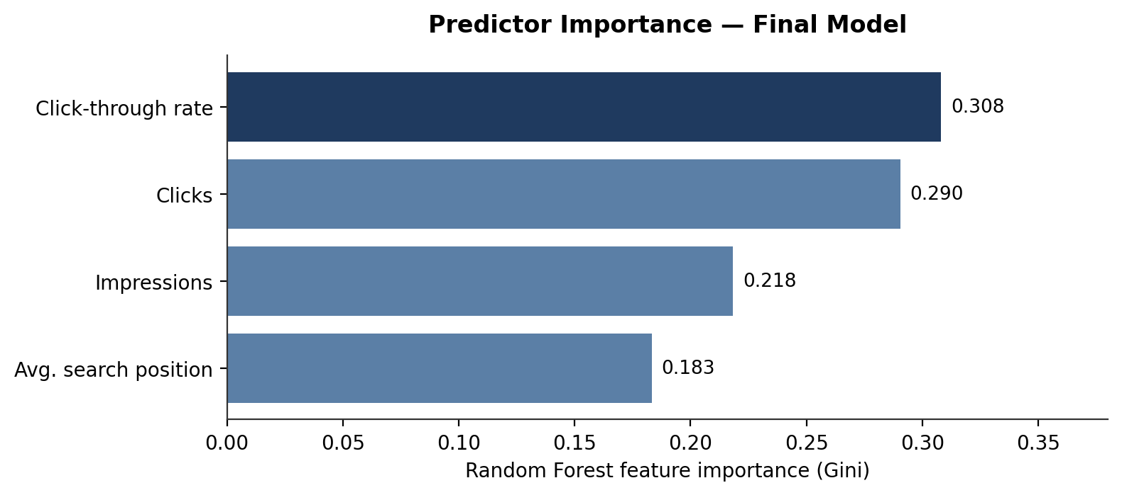
Figure 3. Gini importance from the final random forest. Click through rate is the single strongest predictor of a subsequent decline, ahead of raw click and impression volume.

Threshold Tuning
The default 0.50 probability threshold is not necessarily the right operating point for a review queue use case, where a missed decline (false negative) costs more than an unnecessary review (false positive). Sweeping the threshold from 0.30 to 0.60 on the final GSC only random forest traces a familiar precision/recall trade off.
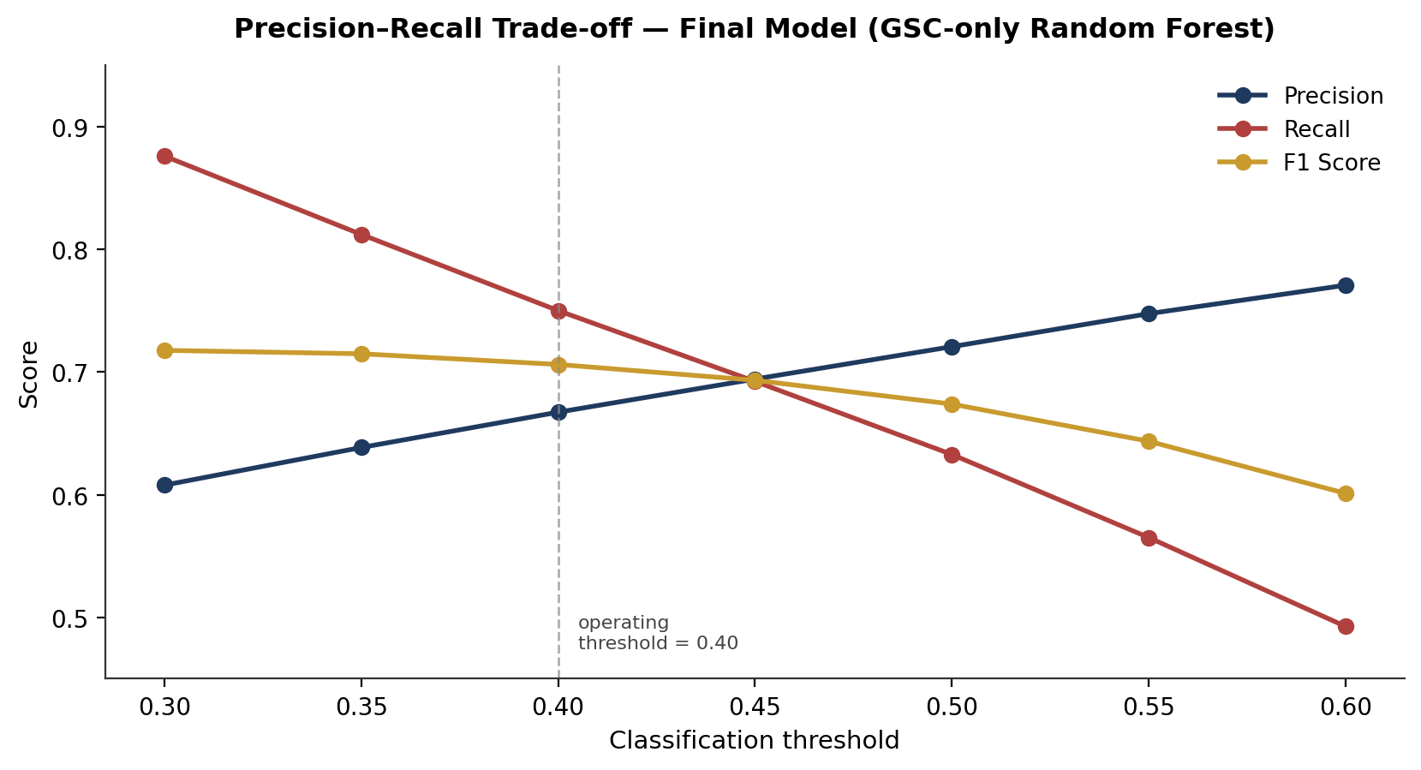
Figure 4. Precision, recall, and F1 as a function of classification threshold, final model. A threshold of 0.40 was selected as the operating point for the recommendation engine, favoring recall over precision.
Threshold | Accuracy | Precision | Recall | F1
0.30 | 0.591 | 0.578 | 0.922 | 0.710
0.35 | 0.630 | 0.616 | 0.847 | 0.714
0.40 (operating point) | 0.660 | 0.667 | 0.750 | 0.706
0.45 | 0.664 | 0.690 | 0.697 | 0.693
0.50 (default) | 0.667 | 0.721 | 0.633 | 0.674
0.55 | 0.659 | 0.748 | 0.565 | 0.644
0.60 | 0.644 | 0.771 | 0.493 | 0.601
Table 3. Threshold sweep, final GSC only random forest. At the selected 0.40 operating point, the model correctly identifies 75.0% of genuinely declining content.
At the 0.40 operating threshold, the confusion matrix on the 215,552 row test set was: 54,316 true negatives, 43,891 false positives, 29,330 false negatives, and 88,015 true positives. In practical terms, three in four truly declining items are surfaced for review, at the cost of roughly two review worthy false alarms for every three correct flags a trade off judged reasonable for a triage tool whose downstream action is “add to a review queue,” not “automatically take a page down.”

Limitations & Honest Framing
The results in this paper should be read as decision support signals, not forecasts or diagnoses, for the following reasons:
- Correlational, not causal. Nothing here identifies why a page's clicks might fall not a specific Google algorithm change, not a competitor's action, not a content quality judgment. The model observes that certain patterns in impressions, clicks, CTR, and position historically preceded a decline; it does not explain the mechanism.
- Modest, not dramatic, lift. A ROC AUC of 0.722 against a 0.702 baseline is a real but incremental improvement. This model is well suited to help a team decide where to look first among hundreds of thousands of items; it is not precise enough to be treated as a confident forecast for any single page.
- A negative result worth keeping. Adding GA4 engagement data and more complex models did not outperform a simple GSC only random forest, most plausibly because GA4 coverage was inconsistent (missing for 63.6% of windows) across the 70 client accounts. A team with more uniform analytics coverage might see a different outcome; this dataset did not support it.
- One dimension of “decline.” The label captures a drop in click volume only. It does not distinguish losing high value transactional traffic from losing low value long tail traffic, and does not weight declines by business importance that judgment is left to the human reviewer using the reason codes below.
- Distributional drift between periods. The positive class rate was 48.8% in the training period versus 54.4% in the test period, suggesting the overall rate of decline was not perfectly stable across the observed 17 months. Recommendations should be refreshed periodically rather than treated as a one time score.
- Excluded accounts. Three client accounts with no usable Search Console signal were excluded entirely; findings apply to accounts with active search visibility during the observed window.
- Binary, not graded, severity. The model does not distinguish a 40% decline from a 90% decline both are “declining.” Severity ranking in the recommendations below comes from the model's predicted probability, used as a proxy for confidence, not from the underlying magnitude of decline.

Ranked Recommendations Action Playbook
The intended deployment output of this work is not a single score but a ranked queue: every eligible content item receives a decline probability from the final model, and each flagged item is paired with a reason code drawn from which observation window signals most resemble the historical decline pattern. The bands below translate model probability and reason code into a concrete next action.
Priority Refresh
Decline probability ≥ 0.65 AND meaningful observation window volume (≥100 impressions).
Reason code driver: compound clicks, CTR, and position are all weakening together.
Action: place at the top of the weekly review queue; treat as a content or on page refresh candidate first.
CTR / Metadata Review
Decline probability 0.45–0.65 AND click through rate is the dominant driver relative to position and impressions.
Reason code driver: CTR compression impressions and position are comparatively stable, but the click through rate has weakened.
Action: review title tag, meta description, and SERP snippet presentation before touching the body content.
Position / Relevance Review
Decline probability 0.45–0.65 AND average position is the dominant driver.
Reason code driver: position slip the page is losing rank even where demand (impressions) has held up.
Action: review content freshness, depth, and competitive relevance; check for newer competing pages outranking this one.
Monitor
Decline probability 0.30–0.45, or eligible volume below the 100 impression floor.
Action: no immediate action; re score on the next 30 day cycle. Useful as an early warning watchlist rather than a queue item.
Protect / No Action
Decline probability below 0.30.
Action: exclude from the review queue this cycle; performance is stable or improving by the model's read of recent signals.
Post Hoc Filter Applied After Scoring
Items currently flagged is_deleted in dim_content are removed from the final list regardless of score, since deletion reflects current state rather than a within window event and a deleted page cannot be “refreshed.”
This structure is deliberately conservative about what the model is asked to decide. It decides ranking and rough cause of decline category; it does not decide whether a flagged page is actually worth saving that remains a human, business context judgment the model has no visibility into.

Reproducibility
All steps described in this paper data discovery, coverage auditing, population filtering, target exploration and sensitivity analysis, leakage checked window construction, feature engineering, model training and evaluation, threshold tuning, and feature importance analysis are implemented in the capstone notebook and are runnable end to end against the public Hugging Face warehouse release with a personal, read only access token.
- Repository structure: work/ contains every weekly assignment notebook plus the capstone notebook (ML_Capstone.ipynb); submission/paper_url.txt contains the single deployed URL for this paper.
- Data access: FlyRank/internship warehouse on Hugging Face, queried via DuckDB over hf:// paths; no credentials or tokens are stored in the repository.
Random seeds (random_state = 42) were fixed for every model to make the reported metrics exactly reproducible given the same warehouse snapshot; because the underlying warehouse is a live, append only dataset, results generated at a later date may differ slightly if the observed history has grown.

Acknowledgments & Data Credit
Built on the FlyRank ML Internship dataset https://flyrank.ai.
Thanks to the FlyRank ML Internship program for curating and hosting a real, large scale, public safe search performance warehouse, and for structuring the capstone around an honest validation standard rather than a leaderboard metric.

